 

**NAAN MUDHAVALVAN - SALESFORCE REPORT**

SUPPLY LEFTOVER FOOD TO POOR

## DEPARTMENT OF COMPUTER SCIENCE AND ENGINEERING

**SREE SAKTHI ENGINEERING COLLEGE**

**TEAM LEADER:**

|  |  |  |
| --- | --- | --- |
| **GOWTHAM S** | **-** | **713621104015** |

**TEAM MEMBERS:**

|  |  |  |
| --- | --- | --- |
| **KARTHI S** | **-** | **713621104023** |
| **MANOJ E** | **-** | **713621104027** |
| **NITHYARAJ K** | **-** | **713621104313** |

### **REGISTERED EMAIL ID:** kg3647372@gmail.com

 

**TABLE OF CONTENTS**

Project overview 1

Project objective 2

Key Features and concepts Utilized 3

Detailed Steps to Solution Design 4

Testing and Validation 5

Key Scenarios Addressed 6

Conclusion… 7

 

# Project Overview

# The endeavor to supply surplus food to those in need underscores the effective redistribution of excess food from a variety of sources, including restaurants, event coordinators, food producers, and private households. The primary aim is to combat food waste by transforming leftover food into nourishment for individuals facing food insecurity, thereby improving food security and alleviating hunger. Salesforce, a leading customer relationship management and cloud platform, can play a vital role in optimizing and managing this initiative by harnessing its technology to develop a unified system that promotes communication and collaboration among food donors (such as restaurants and individuals), volunteers, and charitable organizations, ensuring the swift delivery of surplus food to those in need.

**Objectives**

1. **Facilitate Real-Time Coordination** : Effective real-time coordination is essential for the efficient redistribution of food resources. The system will incorporate functionalities such as instant notifications for donors and volunteers regarding collection and delivery timelines. Integration of GPS technology will enable the tracking of vehicles, ensuring that food is delivered promptly. A mobile application will inform drivers and volunteers of any alterations in routes or pickup locations, thereby minimizing delays.

2. **Optimize Resource Allocation:** By utilizing Salesforce's data analysis capabilities, the platform will assess donation trends and demand fluctuations to ensure optimal resource allocation. For instance, excess food from urban centers can be redirected to adjacent areas experiencing significant food insecurity. Additionally, resource optimization will encompass load balancing for transportation and the strategic assignment of staff to enhance overall efficiency.

3.**Strengthen Community Involvement** :The platform will offer community engagement tools, including a portal for local businesses, educational institutions, and households to enroll as donors or volunteers. It will enable campaigns that focus on raising awareness regarding food waste and fostering active participation. Furthermore, the platform will highlight success stories and testimonials to encourage others to take part in the initiative.

 

## Integrate AI-Powered Features

## The Salesforce Einstein platform harnesses predictive analytics to estimate food demand, drawing insights from historical data, seasonal trends, and local events. In addition, artificial intelligence will streamline delivery routes, enhancing efficiency in terms of time and fuel usage. Machine learning techniques can also predict the shelf life of donated food, facilitating better prioritization in its distribution

## Enable Customizable Reporting

## Various stakeholders, including non-governmental organizations, donors, and governmental bodies, will be granted access to interactive dashboards that deliver real-time reporting. These dashboards will monitor essential metrics, such as the volume of food contributions, the number of beneficiaries assisted, and the hours volunteered. Additionally, reports can be tailored to address specific requirements, such as evaluating regional outcomes or strategizing for upcoming initiatives.

# Salesforce Key Features and Concepts Utilized

## Salesforce CRM for Donor Management:

## Unifies donor records, making it easier to track donations, preferred delivery methods, and the frequency of contributions, thus promoting effective communication with donors.

* + **Salesforce Lightning Platform for Custom App Development**:

Unifies donor records, making it easier to track donations, preferred delivery methods, and the frequency of contributions, thus promoting effective communication with donors.

* + **Salesforce Communities for Collaborative Engagement**:

Unifies donor records, making it easier to track donations, preferred delivery methods, and the frequency of contributions, thus promoting effective communication with donors.

 

## Salesforce Einstein Analytics for Data Insights:Leverages AI technology to project trends related to food donations, the readiness of volunteers, and the necessities of recipients, facilitating improved resource management and more effective decision-making.

## Salesforce Flow for Process Automation: Enhances the efficiency of operations by refining processes such as the collection of food donations, the assignment of tasks to volunteers, and the communication of food availability to recipients.

## Integration with External Systems (MuleSoft): Supports uninterrupted data communication between Salesforce and various external systems, such as food bank databases and logistics tools, leading to improvements in the food redistribution process.

## 

* + **Volunteer Training and Resources**: The platform can serve as a repository for training content and directives for volunteers, guaranteeing that they are sufficiently prepared for tasks related to food collection and delivery.
  + **Real-Time Analytics for Operational Efficiency**: Through its real-time reporting and analytics capabilities, Salesforce aids in the oversight of logistics, ensuring that food collection,sorting, and distribution to recipients are conducted efficiently.

 

# Detailed Steps in Solution Design

## Step 1: Requirement Gathering

* + Identify stakeholders: food donors, volunteers, profit organizations, and food recipients.
  + Gather requirements for food donation processes, food safety standards, and logistics.

## Step 2: Designing the Salesforce Application

* + **Salesforce Objects**: Create custom objects for food donations, volunteers, recipients, and food types (e.g., categories such as perishable, non-perishable).
  + **Custom Fields and Records**: Define fields such as food quantity, pick-up time, delivery time, and donor contact information.
  + **Salesforce Communities**: Design a portal where donors can post available food, and volunteers can sign up to pick up and deliver food.

## Step 3: Automating the Process with Flows and Workflows

* + Use **Salesforce Flow** to automate the process. For example, a flow could automatically generate a task for a volunteer to pick up food once a donation is made.
  + Notifications and reminders can be sent through **Salesforce Workflow Rules** to ensure tasks are completed on time.

## Step 4: Integration with External Systems

* + Use **MuleSoft** or other integration tools to connect Salesforce with third-party applications (e.g., delivery apps, food tracking systems).

## Step 5: Testing and User Feedback

* + Test the system with a small group of users, including food donors,recipients, and volunteers.
  + Collect feedback and make necessary adjustments to the applications

 

**Procedure of Project**

# Salesforce Developer Account Creation

## Visit the Website

Go to <https://developer.salesforce.com/>and click **"Sign Up"**.

## Fill in Details

Provide your name, email, company (if applicable), and a unique username in email format.

## Verify Email

Check your inbox for a verification email and activate your account.

## Set Password

Create a password and security question following Salesforce guidelines.

## Login and Explore

Access your Developer Org at <https://login.salesforce.com/>and familiarize yourself with the tools like **Setup** and **Developer Console**.

# Creating Objects in Salesforce

Objects in Salesforce are used to store data and represent tables in the database. Custom objects can be created to fit the specific needs of the project. Below is the process for creating objects:

## Navigate to Setup

Log in to the Salesforce Developer Org.

Click on the **Gear Icon** (Setup) in the top-right corner.

## Create a New Object

In the Quick Find box, search for **"Object Manager"** andclick on it.

Click on **"Create Object"** and choose **Custom Object**.

 

1. **Define Object Details:** Enter the **Object Label**

The **Object Name** is automatically generated (e.g., Food_Donation c). Check the box for **Allow Reports** to enable reporting features for the object. o Save the object.

## Add Custom Fields

After creating the object, add fields to store specific data,such as:

* + Text Field for Donor Name.
  + Number Field for Quantity.
  + Date-Time Field for Pickup Time .

## Page Layout and Visibility

Customize the page layout to display fields in a user- friendly manner. Set object permissions for different userprofiles as required.

## Figure 1 :

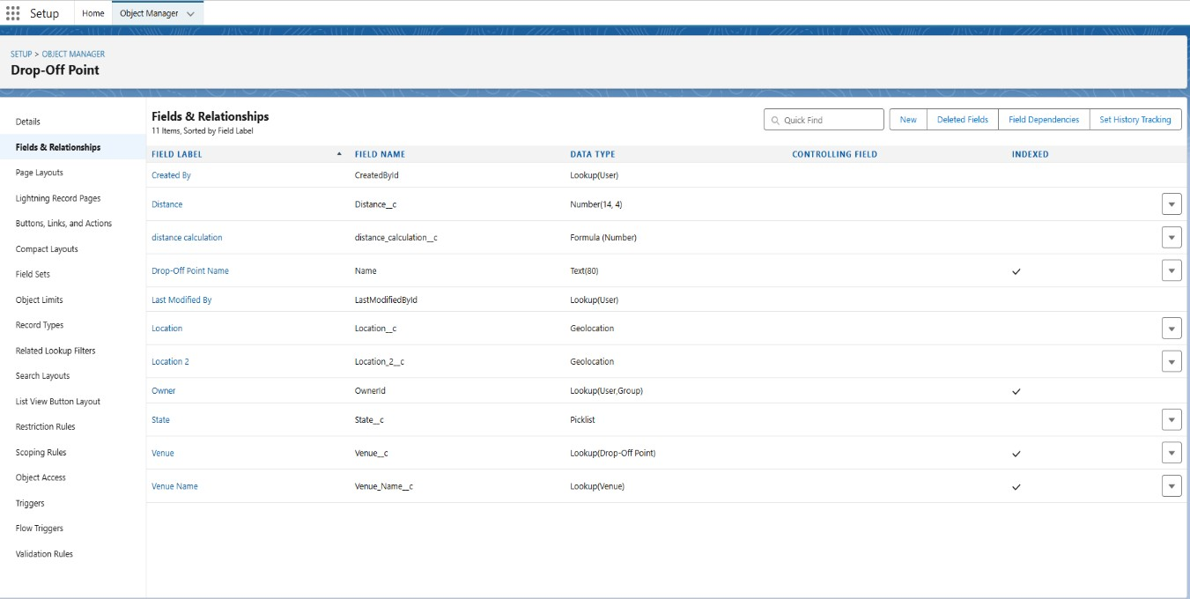

 

# Creating Tabs for Custom Objects

Tabs in Salesforce provide a user-friendly way to access and manage custom objects from the application interface. Below are the steps to create tabs for the custom objects:

## Navigate to Tabs Setup

* + Go to **Setup > User Interface > Tabs**.
  + Under the **Custom Object Tabs** section, click **"New"**.

## Create Tabs for Each Object

1. **Venue Tab**
   * Select the custom object **"Venue"** from the dropdown.
   * Choose a suitable tab style (e.g., Building icon).
   * Click **Next** and set visibility for profiles (select as needed).
   * Save the tab.

## Drop-off Point Tab

* + Select the **"Drop_Off_Point"** object.
  + Pick an appropriate tab style (e.g., Map Pin icon).
  + Configure visibility and save.

## Task Tab

* + Choose the **"Task"** object.
  + Use a relevant tab style (e.g., Clipboard icon).
  + Set Visibility Preference and Save .

 

## Volunteer Tab

* + Select the **"Volunteer"** object.
  + Choose a tab style (e.g., People icon).
  + Configure visibility settings and save.

## Execution Details Tab

* + Pick the **"Execution_Details"** object.
  + Select a tab style (e.g., Checklist icon).
  + Set visibility and save.

**Figure 2 :**

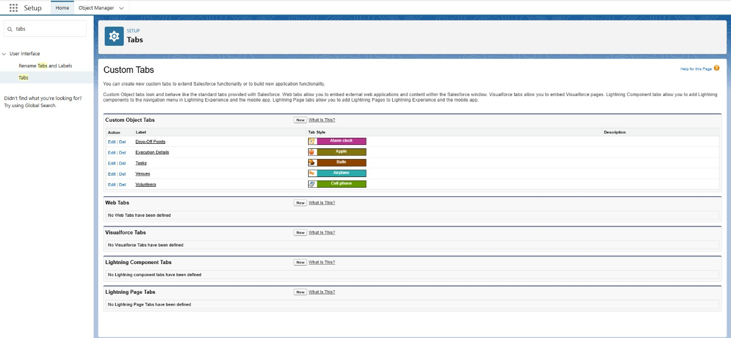

# Adding Fields

Fields are created in each custom object to capture and manage specific data.

## Venue Object

* + **Venue Name** (Text).
  + **Location** (Geolocation).
  + **Capacity** (Number).

 

## Drop-off Point Object

* + **Point Name** (Text).
  + **Address** (Text Area).
  + **Contact Number** (Phone).

## Task Object

* + **Task Description** (Text Area).
  + **Due Date** (Date).
  + **Assigned Volunteer** (Lookup to Volunteer).

## Volunteer Object

* + **Volunteer Name** (Text).
  + **Contact Number** (Phone).
  + **Availability** (Picklist: Available, Not Available).

## Figure 3 :

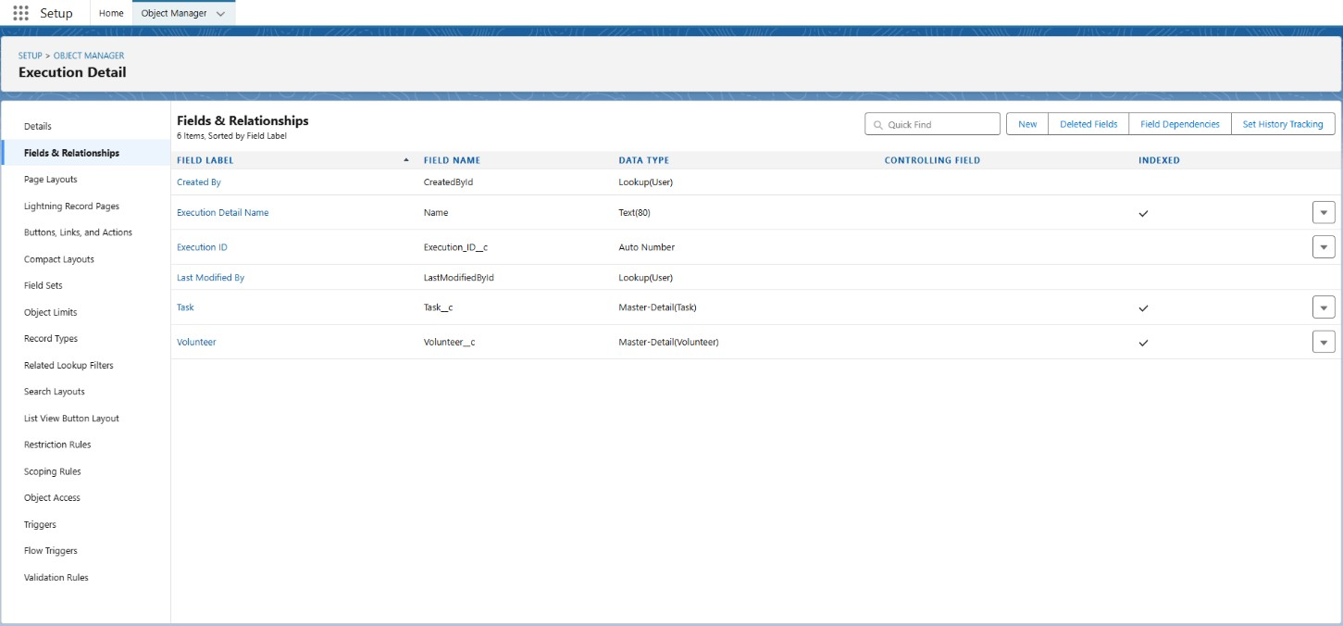

1. **Execution Details Object**
   * **Task Reference** (Lookup to Task).
   * **Status** (Picklist: Pending, In Progress, Completed).

 

* + **Completion Date** (Date).

# Creating Users

1. **Navigate to User Setup** o Go to **Setup > Users > Users** and click

## "New User".

1. **Enter User Details**

Fill in **First Name**, **Last Name**, **Username**, **Email**, **Profile**,and **Role**.

Choose **License** and set the user as **Active**.

## Save User

Click **Save** to create the user.

# Creating Public Groups

Public Groups help organize users for sharing records and collaboratingin Salesforce.

## Navigate to Public Groups Setup

Go to **Setup > Administration > Manage Users > Public Groups.**

Click **"New Group"**.

## Define Group Name

Enter a **Group Name** (e.g., "Food Donors","Volunteers").

## Add Group Members

Click **Add Members** and select users, roles, or other groups to include.

1. **Save Group** Click **Save** to create the group.

 

# Creating Custom Report Types

To create custom report types in Salesforce, navigate to Setup > Create > Report Types and click "New Custom Report Type". Select the primary object (e.g., Food Donation, Task) and enter a Report Type Label with a description. Define the relationship between objects, such as linking tasks to food donations,and set the report type to "Deployed" for availability. Finally, click Save to create the report type. Custom report types allow for detailed, tailored reporting, offering insights into various aspects of the project. Custom report types allow for detailed, tailored reporting, offering insights into various aspectsof the project.

**Figure 4 :**

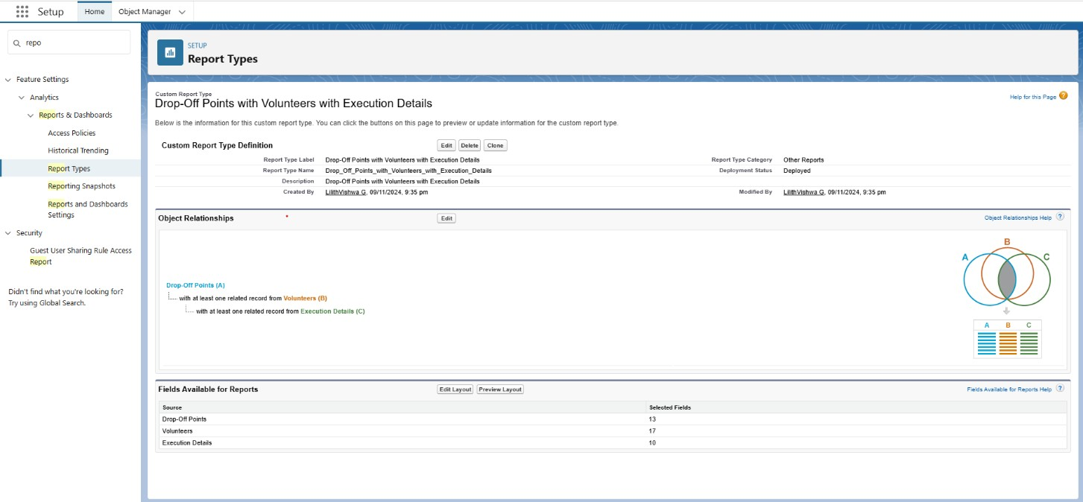

# HOME PAGE

The **Home Page** serves as the central hub for the application, offering a structured view of critical information and actions for managing the project effectively. It is divided into three primary panels, each designed to address specific functionalities.

 

## Left Panel:

* **Purpose:**

Displays a comprehensive list of available drop-off points and their corresponding venues.

## Details:

The panel includes entries like *"*Supply Food*"* and *"*Chino Foundation*,"* providing quick identification of food supply locations and associated organizations.

Provides an overview of tasks assigned to volunteers.

## Current Status:

At this stage, the section does not display any data,indicating that no volunteer tasks have been created or assigned yet.

## Potential Updates:

This panel could dynamically update to show tasks with details such as task name, assigned volunteer, and completion status as the project progresses.

## Right Panel:

* **Purpose:** Serves as a venue entry form, enabling users to input new venue details.
* **Features:** Input fields for essential details, including:
  + Name
  + Phone Number
  + Location
  + Latitude and Longitude
* A **“Next” button** signifies a multi-step process, indicating that additional details or steps may follow for completing the venue registration.

 

**Figure 5 :**

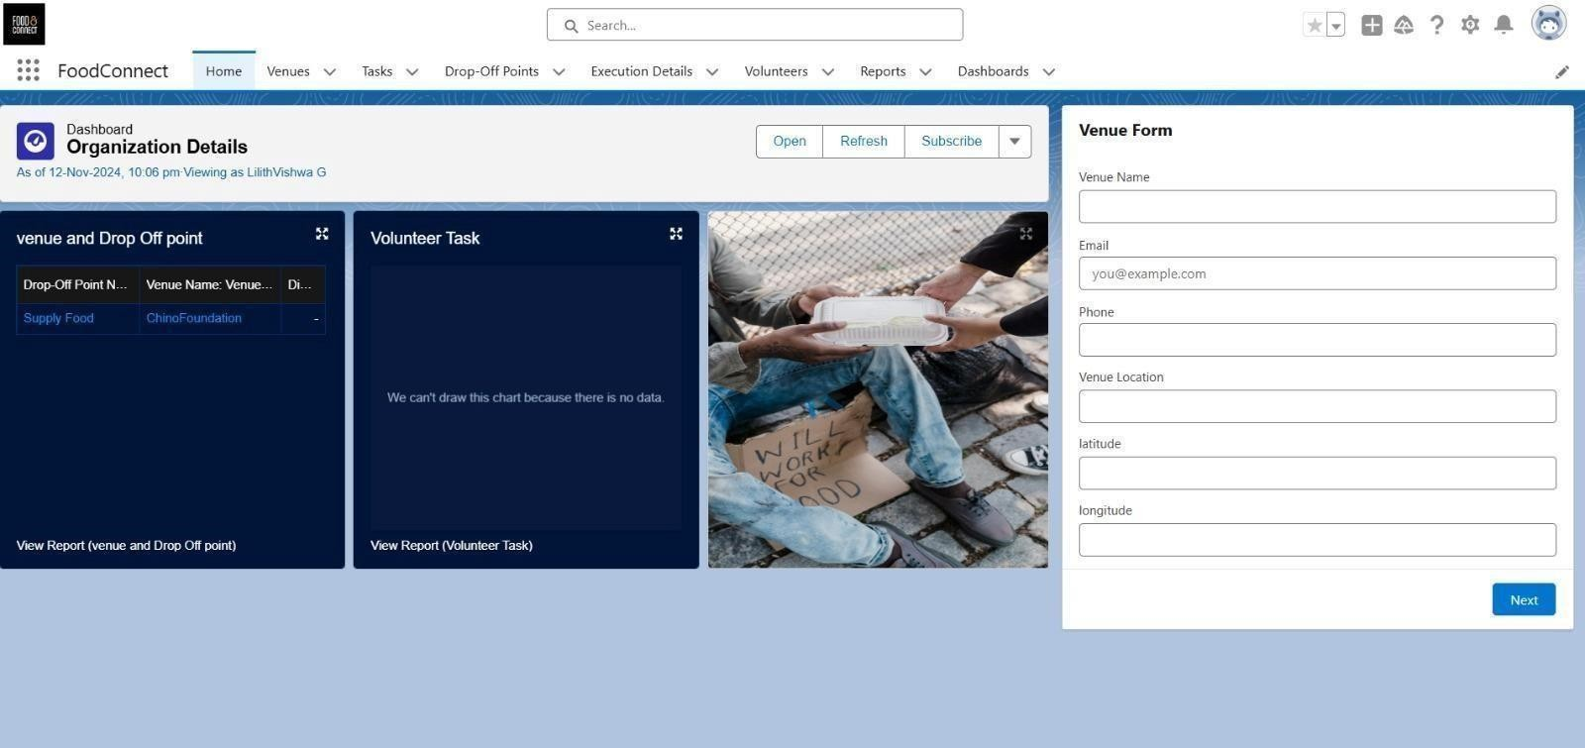

**Flows**

## Start Node

* + **Purpose:** Marks the entry point of the flow, where the process is initiated.
  + **Trigger:** The flow begins when a user interacts with the form or performs an action to create a venue record.
  + **Significance:** Ensures that the flow is systematically activated, establishing a clear beginning for the data entry and management process.

## Venue Details Screen

* + **Purpose:**

Serves as an interactive user interface (UI) for collectingvenue- related information.

## Features:

Users can input critical details such as:

* + - Venue Name
    - Email Address
    - Contact Phone Number
    - Physical Location

 

## Create Venue Record

* + **Purpose:**

Automates the creation of a new record in the system using the information provided by the user.

## Process Details:

Once the user completes the Venue Details Screen, the flow takes the collected data and processes it. o A new venue record isthen created in the system database with fields populated based on the user’s inputs.

## Outcome:

Ensures data integrity and reduces manual effort in record creation. Provides instant feedback to users, confirming thatthe venue has been successfully added.

## Figure 6 :

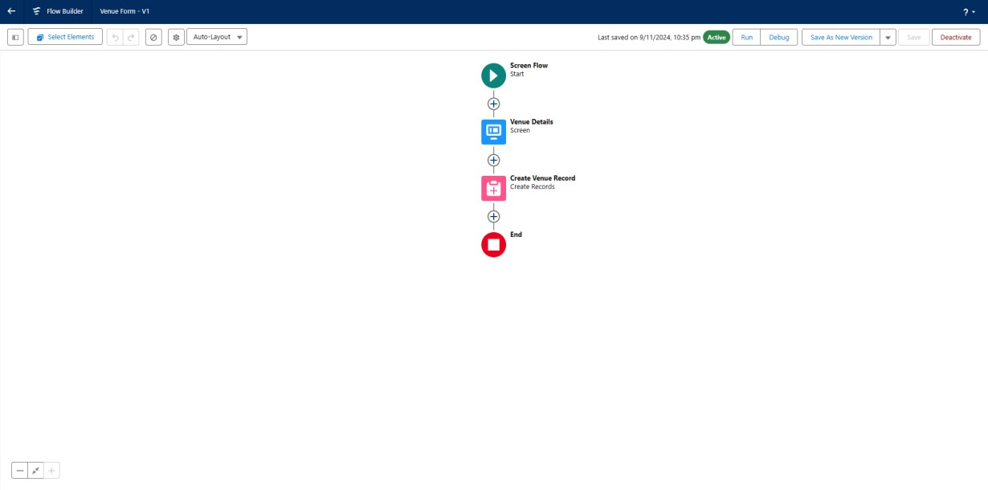

**Purpose of the Flow:**

The **"Venue Form - V1"** flow simplifies the process of venue management by providing a streamlined and automated approach to data collection and record creation. This ensures accuracy, efficiency,and user satisfaction while reducing manual workload for administrators.

 

# DEVELOPER CONSOLE :

The **Developer Console** in Salesforce is utilized to manage and test custom code. In this case, it is used to create and execute an **Apex Trigger** named **DropOffTrigger**. This trigger automates a key process by populating the Distance_c field of the Drop_Off_point_cobject during record creation. Below is a detailed explanation of the trigger's functionality and implementation.

## Apex Trigger: DropOffTrigger

The **DropOffTrigger** is a custom Apex trigger that enhances automation within the Salesforce system by performing calculations before inserting new records into the Drop_Off_point_c object.

## Key Details:

1. **Trigger Event:**

The trigger is executed **before insert**. o This ensures that the required fields, such as Distance_c, are populated before the new record is saved to the database.

## Purpose:

Automatically calculates and populates the Distance_c field with the value of distance_calculationc. o Simplifies the process, reducing manual data entry and ensuring consistent calculations.

## Structure:

* + The trigger uses a **simple for loop** to iterate over the list of newrecords (Trigger.new).
  + During each iteration, the Distance_c field of the current record is set to the value derived from the distance_calculationc formula or field.

 

## Code Example:

Below is a conceptual representation of the trigger: apex Copy code

trigger DropOffTrigger on Drop_Off_point_c (before insert) { for (Drop_Off_point_c dropOff : Trigger.new) { dropOff.Distance_c = dropOff.distance_calculationc;

}

}

# Figure 7 :

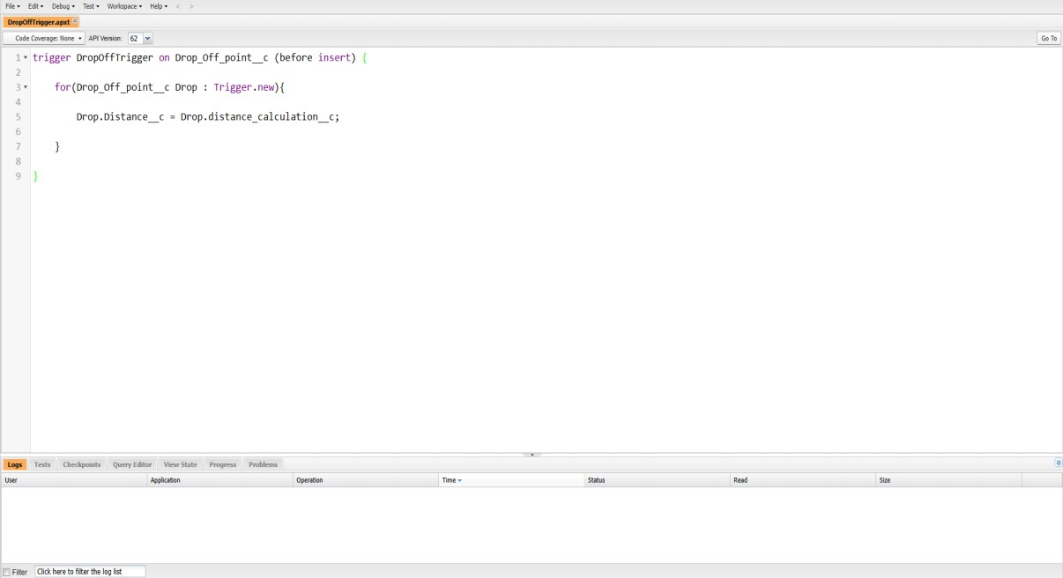

## Benefits of the Trigger:

* + **Automation:** Reduces manual effort by automatically populating the field during record creation.
  + **Data Integrity:** Ensures the Distance_c field is consistently calculated and populated for all new records.
  + **Efficiency:** Simplifies workflows by eliminating the need for additional user actions or processes.

 

## Purpose of the Developer Console in This Context:

* + **Debugging:** The Developer Console provides an environment to test and debug the trigger to ensure it performs as expected.
  + **Testing:** Developers can simulate the creation of records to validate the accuracy of the Distance_c calculations.
  + **Optimization:** Enables quick iterations and improvements to the trigger logic if necessary.

# REPORT

The **"Reports"** section within the **FoodConnect platform** is designed to provide users with a comprehensive view of data related to venues, drop-off points, volunteer tasks, and system workflows. This functionality aids in monitoring, analyzing, and improving the efficiency of various processes. Below is a detailed breakdown of the section and its components.

## Key Features of the Reports Section:

1. **Available Reports:**

* Provides insights into the relationship between venuesand drop-off points.
* Helps in understanding the distribution of resources and optimizing logistics.
* Offers details on the usage and performance of screenflows within the platform.
* Useful for tracking user interactions and ensuring theeffectiveness of flow designs.

 

## Report Organization:

* + **Name:** Clear titles for each report, enabling users to quickly identify relevant data.
  + **Description:** Provides a brief overview of the report’s purpose and contents, ensuring clarity.
  + **Folder Location:** Indicates where the report is stored, facilitating easy navigation within the platform.
  + **Creator:** Displays the name of the user who created the report, ensuring accountability and reference.
  + **Creation Date:** Records the date the report was generated, allowing users to track updates and relevance.
  + **Subscription Status:** Shows whether users have subscribed to receive periodic updates or notifications about the report.

# Figure 8 :

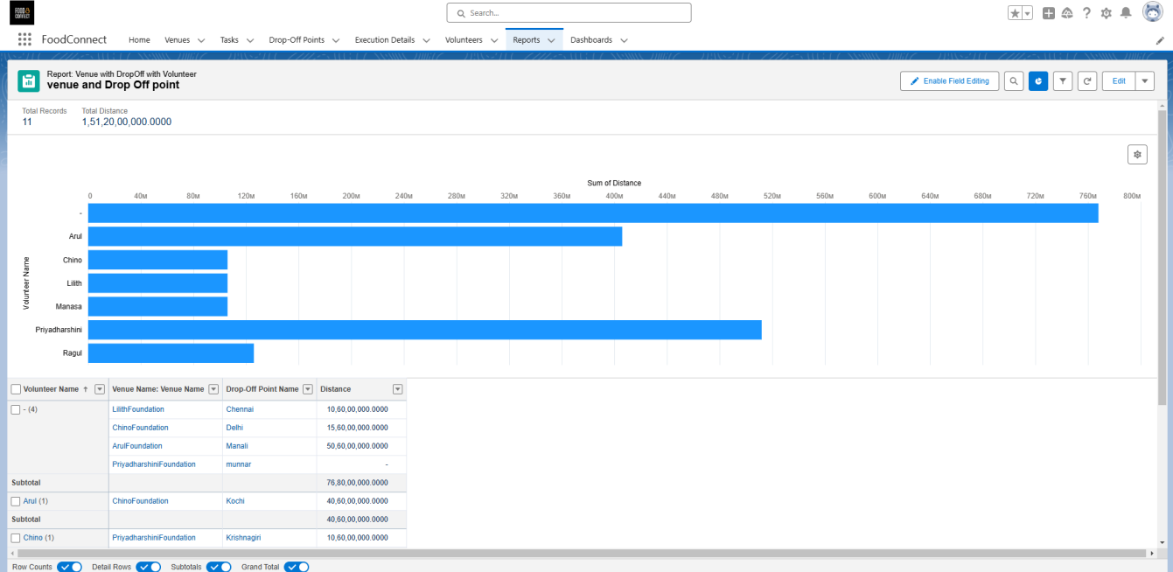

**DASHBORD**

The **Dashboard** in the **FoodConnect platform** is a powerful feature that consolidates essential information into a visually intuitive interface. It serves as a

 

central hub for monitoring, analyzing, and managing key provider-related data. Designed for user convenience, the dashboard combines statistics, charts, and summaries to enable quick insights and decision-making.

## Key Features of the Dashboard:

1. **Comprehensive Overview of Provider Information:**
   * Displays detailed data about providers, including names, contactdetails, locations, and service areas.
   * Highlights key metrics such as the number of active providers, completed tasks, and ongoing projects. o Ensures transparency bypresenting all provider-related information in a centralized location.

## Data Statistics:

* + Summarizes critical data points into easily digestible formats, such as total resources distributed, average volunteer participation, and event success rates. o Offers numerical summaries to highlight keyperformance indicators (KPIs).

# Figure 9 :

## Charts for Easy User Understanding:

Includes various chart types, such as:

* + **Bar Charts:** To compare provider contributions or venue performance over time.
  + **Pie Charts:** For visualizing resource distribution across different locations or providers.

 

* + **Line Graphs:** To track trends like increasing volunteer participation or declining resource availability.
  + Charts are interactive, allowing users to drill down into specificdata points for deeper insights.

# Figure 10 :

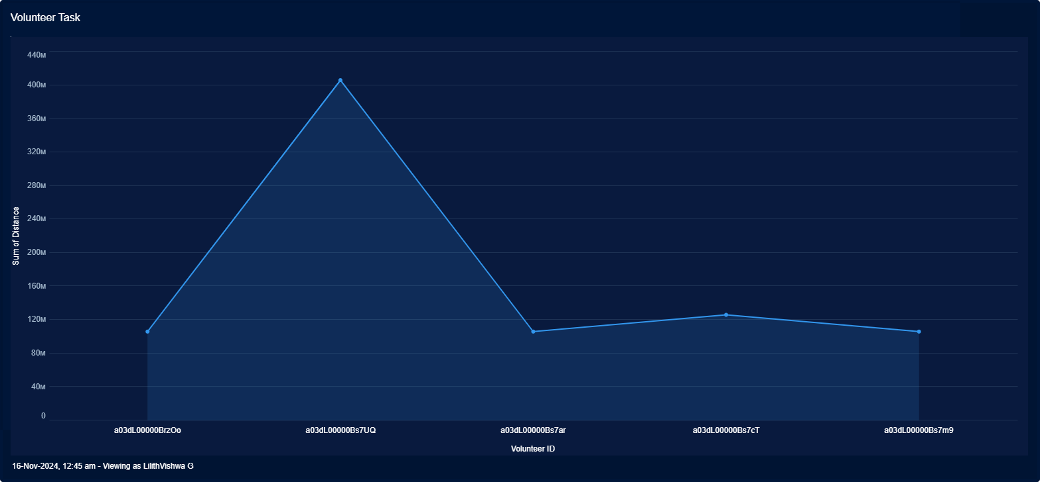

1. **Testing and Validation**
   * **Unit Testing**: This phase involves testing each individual component of the platform to verify its functionality in isolation. For instance, food donation forms are tested to ensure that they correctly capture and process donor information.
   * **Volunteer assignment** : logic is tested to ensure that volunteers are appropriately matched to tasks based on availability and location.
   * **Integration Testing**: Once individual components are tested, the next step is to ensure that these components work together as a unified system.
   * **User Acceptance Testing (UAT)**: UAT is conducted with real food donors, volunteers, and recipients to ensure that the system meets the expectations and requirements of its end users.

 

# Key Scenarios Addressed

## Food Donation Process

## The Salesforce platform automates the procedure by which donors contribute surplus food, enabling volunteers to be alerted and assigned tasks related to the collection and distribution of the food. This system enhances the coordination between donors, volunteers, and recipients, effectively streamlining the overall food donation process.

## Volunteer Management

## The platform assesses volunteer availability and designates them to specific tasks in alignment with their schedules and proximity to food donation centers. This method ensures timely collection and delivery of food, thereby optimizing operational efficiency

## Recipient Management

## Salesforce takes measures to ensure that food recipients undergo a thorough verification process, with deliveries scheduled to align with their particular needs. This approach guarantees that food is distributed to those who are eligible, thereby enhancing the trustworthiness and reliability of the system.

## Real-time Notifications

## Notifications regarding food availability, pick-up, and delivery times are communicated in real-time to donors, volunteers, and recipients. This approach ensures that everyone remains informed and fosters efficient communication, ultimately decreasing the likelihood of delays and misunderstandings.

## Reporting and Analytics

## The platform leverages Salesforce's Einstein Analytics to manage important metrics, such as the total food donated, the number of individuals served, volunteer involvement rates, and the efficiency of delivery operations. This data is essential for identifying trends and streamlining the food distribution process, ultimately leading to greater impact and improved resource management.

 

# Conclusion

# This initiative, driven by Salesforce technology, seeks to connect surplus food with individuals facing food insecurity, merging technological innovation, social responsibility, and data analytics. By employing Salesforce’s cloud-based CRM, automation tools, and analytical capabilities, the program is equipped to expand its reach to various communities. The seamless integration of volunteers, food donors, and recipients on a centralized platform promotes the effective redistribution of excess food, thus reducing waste and combating hunger. With rigorous testing, real-time tracking, and an emphasis on community participation, this initiative has the potential to significantly enhance food security while encouraging sustainable practices in the food industry. By leveraging the strengths of Salesforce, this project not only refines the redistribution process but also establishes a framework for similar initiatives worldwide, ensuring that surplus food is transformed into nourishment for those who require it most.